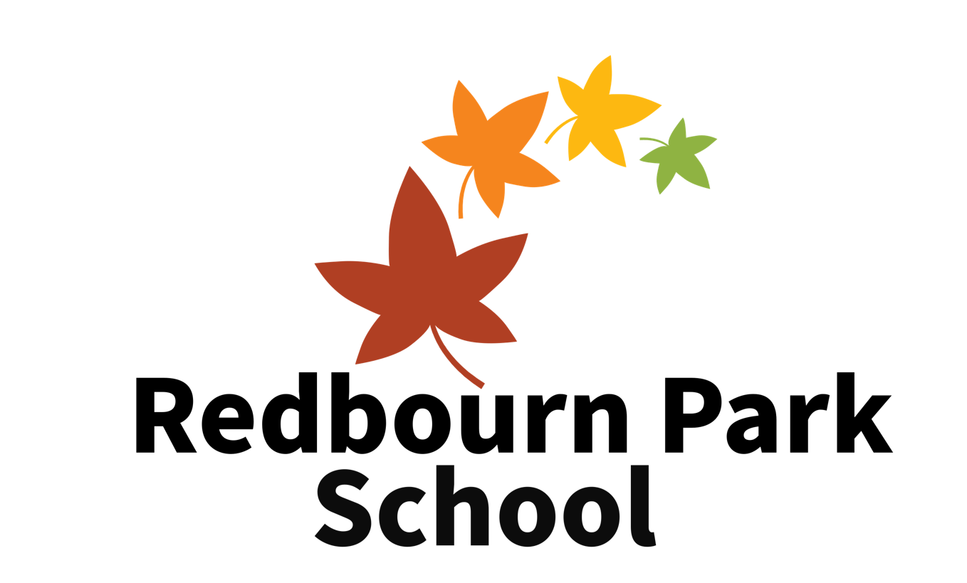
Health & Safety Policy

Including policies and procedures on risk assessments
See also, ‘Who we are, what we do and how we do it’, Physical intervention and First and Medical conditions policies

Our vision is to provide students with the best opportunities possible to be positive and successful members of their communities. We do this by developing the whole student as well as focusing on their academic development. We do this through high quality, positive teaching and support and three core beliefs underpin everything we do:

Everyone has the potential to achieve

We have high expectations on ourselves and others

We respect ourselves and others

This policy was updated on: September 2023
This policy was created on: October 2020

Introduction
This document states our aims, principles and strategies for ensuring a high standard of Health & Safety at Redbourn Park School, Grovehill YC, Stevenage Rise, Hemel Hempstead, HP26BH.
Redbourn Park School aims to provide a safe and healthy working and learning environment for staff, students and visitors at all times and recognises and adheres to The Health and Safety at Work Act 1974 and Risk Assessments: The Management of Health and Safety at Work Regulations 1999. As a result, we recognise that it is our duty to manage our school in such a way as to ensure, so far as is reasonably practicable, that anybody at Redbourn Park School is not exposed to risks to their health and safety.
We accept that we have a responsibility to take all reasonably practicable steps to secure the health and safety of students, staff and others using the school premises and believe that the prevention of accidents, injury or loss is essential to the efficient operation of the school and is part of the effective education of our students.

Responsibilities
Redbourn Park School recognizes that it everyone plays a role in ensuring the safety of themselves and each other and within this section, aims to identify responsibilities that staff, students and wider members of the community

The Leadership Team
- Providing and maintaining a safe and healthy learning environment, equipment and systems of work for all our employees and the students we provide education to. We will provide them with such information, training and supervision, as they need for this purpose.
- Recognising that there are higher levels of risk due to the nature of our students and providing further training to staff to be able to safely manage any behaviours that may pose any higher risks. Likewise, our employees have a responsibility, which includes taking reasonable care of their own health and safety and that of others that may be affected by what they do or do not do.
- Recognising a greater level of care and vigilance is required in our schools for our students and Contractors in terms of safety procedures, within the vicinity of the school building.
- Establishing a system for reporting, recording and the investigation of accidents and near-misses and ensuring that this is applied rigorously.
- Monitoring and reviewing this policy, ensuring that necessary revisions are undertaken.
- Ensuring all staff are familiar with the Health and Safety policy of the school.
- Taking active steps to ensure that equipment, buildings and grounds are safe, secure and well maintained and that any damage is quickly rectified.
- Continually improving Health and Safety Standards in line with relevant good practice, and not merely within the legal minimum standards.
- Ensuring that there are speedy arrangements for the speedy evacuation of the building in case of fire or other emergency and that firefighting equipment is available and maintained.

Head Teacher
- Taking responsibility for the day-to-day operations of the Health and Safety Policy, delegating practical aspects to the Operations manager

All staff
- Promoting a spirit of safety consciousness and using resources and training to develop the students’ understanding of their own responsibilities in taking reasonable care of their own safety and that of others.
- Being good role models – vigilant and careful.
- Taking quick action to ensure that students are not allowed to jeopardise their own safety or that of others. In cases where the Student is intent on this, using training provided and following the Care and Control Policy to minimise the risk to the student, others and the property of the school.
- Providing opportunities and therapeutic forums to discuss appropriate health and safety issues.
- To make sure risk assessments are carried out before any off-site visits or trips.

Students
- Taking part in a morning meeting with other students and staff to plan the day and discuss issues at the School Council meeting at the end of the day.

Parents/Carers
- Ensuring that the students attend the school in good health.
- Providing prompt communication to explain any absences.
- Ensuring school staff have a full handover regarding any incidents, behaviours and any other matters that have occurred at home which may mean the student could require extra support, understanding or the opportunity to talk with someone before starting their school day.
- Ensuring the school has up to date emergency contact details for parents and other professionals involved in the Students care.

Procedures
Redbourn Park understands that our principles have to be underpinned by effective and robust procedures that are undertaken and reviewed routinely.

To ensure all members of the school community are aware of health and safety, we:
- Have regular discussions to review health and safety issues.

For providing students with opportunities to discuss health and safety:
- Daily meetings at the start of every school day, and school council meetings throughout the term
- A programme of personal and social education designed to promote self-esteem, mutual respect, self-discipline and social responsibility.

For accident prevention, reporting and investigation we have:
- Risk assessments formulated and regularly reviewed.
- Vigilance by staff to recognise potential causes of accidents (to include students’ behaviour) and to act to prevent these where possible.
- Promptness in reporting potential hazards to the Head Teacher and an immediate response to such reports.
- Completion of the appropriate accident reporting paperwork to include any injuries sustained and body map completion if applicable.
- Prompt investigation of all accidents by the Head in order to establish the cause and adopt any remedial measures.

For First Aid provision we have:
- Trained, recognised first aiders in school at all times.
- Provision of fully stocked first aid boxes.
- Summon an ambulance where necessary by any responsible adult and arrange to meet and guide the ambulance if needed. A member of either residential or school staff will accompany a student to hospital.
- All staff will be trained in Emergency First Aid and a list of training dates will be held by the Head Teacher.

For fire precautions we have:
- A dedicated procedure for emergency evacuation which is displayed in the school and is shown to all visitors on their arrival.
- At least termly, recorded fire drill.
- Regular checks of equipment, procedures and exits by the Head Teacher and maintenance of equipment is overseen by Dacorum Borough Council.
- All fire exits clearly signed.
- Dedicated Fire Marshall training for all staff.

For the use and control of substances hazardous to health we have:
- If storage of such substances then they are to be locked and not accessible to students – there is a cleaning cupboard which is locked throughout the day.
- The issue of personal protection equipment (e.g. rubber gloves) when necessary.

For electric safety we have:
- Siting of equipment to avoid trailing wires.
- Annual PAT testing electrical contractors on all portable electrical equipment.

For coping with special medical conditions, we have:
- Information given to all staff about any special medical conditions of students attending the school and about what response may be necessary in an emergency.
- Liaison with parents and carers about any changes in any student’s medical condition.
- A requirement that all medicines brought to school must be clearly labelled with the student’s name along with their dedicated recording sheets, which will inform the dosage and frequency.
- For dispensing of medication (only medication prescribed by the doctor) please see our first aid policy.

For developing understanding around the importance of personal hygiene we:
- Remind and support students day to day to encourage personal hygiene routines, which include students washing their hands after using the toilet and the provision and maintenance of suitable facilities for this.
- A programme of health education.

For ensuring outside safety we:
- Regularly review the use of offsite locations and dynamically assess any risk and take appropriate steps to reduce risk.
- Supervision at all times

For planning and responding to works:
- Head teacher is to be alerted via email if there are any concerns or works required. It is then the role of the Head to organise the works or arrange with the landlords at Dacorum Borough Council.

Risk Assessments
A risk assessment is a tool for conducting a formal examination of the harm or hazard to people (or an organisation) that could result from a particular activity or situation.
- A hazard is something with the potential to cause harm (e.g. fire).
- A risk is an evaluation of the probability (or likelihood) of the hazard occurring (e.g. a chip pan will catch fire if left unattended).
- A risk assessment is the resulting assessment of the severity of the outcome (e.g. loss of life, destruction of property).
- Risk control measures are the measures and procedures that are put in place in order to minimise the consequences of unfettered risk (e.g. staff training, clear work procedures, heat detectors, fire alarms, fire practices, gas and electrical shut down points and insurance).

Accidents and injuries can ruin lives, damage reputations and cost money. Apart from being a legal requirement, risk assessments therefore make good sense, focusing on prevention, rather than reacting when things go wrong. Many cases simple measures are very effective and not costly.
Risk assessments need reviewing and updating regularly. At Redbourn Park School, we are very aware that all staff and students need to receive training. Risk assessment proforma, and completed documents are maintained by the Head Teacher, and are available to all staff.

What activities require a specific risk assessment?
There are numerous activities carried out in Redbourn Park School, each of which requires a specific risk assessment. The most important of these include Fire safety procedures and risk assessments and Educational visits and trips. As a guide we separate risk assessments into 3 tiers:
- Tier 1 – a regular activity that is risk assessed each full term. This may include cooking, PE, use of libraries etc. Permission for these is acknowledged on this form.
- Tier 2 – a one-off trip that is organised but is low/moderate risk. This may include trips to the cinema, for lunch, a museum etc. A risk assessment is created for each trip. Permission for these is acknowledged on this form.
- Tier 3 – a trip that carries a moderate risk and/or additional considerations. This may include swimming, theme parks, go-karting. This requires specific permission for each trip or block booking (a clock of swimming lessons for example). Permission will be sought in writing and we will keep a record of this.

All students have individual risk assessments where the risk is assessed for each activity they undertake. We obtain the venue's general risk assessment and also their public liability insurance and hold that on file, however the students risk assessments will be specific to their needs and potential risks and how we will manage those.
Activities that may require risk assessments include but are not limited to:

Educational
- Food Technology
- Each physical activity
- Art
- Vocational activities
- Travel in the school cars
- Outdoor education activities

At Redbourn Park School, we make use of model or generic risk assessments, for our educational activities and visits. All teaching/school staff receive regular induction and refresher training in risk assessments tailored to their specific areas.

Pastoral
The aim of our pastoral emphasis is to ensure that every student leaves as a confident, articulate young adult capable of keeping him/herself safe on the streets, in the home and in all situations. Our PSHCE and social skills programmes are directed towards promoting an increasing understanding as the student develops, of the risks that exist in both the real and the electronic worlds, and on sensible precautions that should be taken.

Medical and First Aid
The Medical area has risk assessments for first aid and all other treatments and procedures. The accident forms are maintained in the school office, and the Head Teacher is responsible for ensuring that accident reports are passed to the proprietor. In the case of a medical emergency, staff are instructed to dial 999 and ask for emergency services. The Head Teacher is responsible for reporting any notifiable accident that occurs on school premises to a student, member of staff, parent, visitor or contractor, to the HSE in accordance with the Reporting of Injuries Diseases and Dangerous Occurrence Regulations (RIDDOR). (Please see our First Aid policy)

Child Protection
Our Safeguarding policies, and training for all staff form the core of our child protection risk management. Safer recruitment policies and procedures ensure that the school is not exposed to the risk of employing staff who are barred from working with children and are not allowed to work in the UK. By extending this regime to Governors, volunteers, and by ensuring that everyone in our community receives regular child protection training, we manage this risk to an acceptable level. (Please see our Safeguarding policy)

Behaviour
Each student has an individual risk assessment as explained in detail in ‘Risk assessment procedures’. This policy should be read in conjunction with this and also individual risk assessments, Visits and trips risk assessments, policies relating to behaviour management and procedures for dealing with violent and aggressive behaviour. (Please see our What we do & how we do it policy).

Lone Working
It will often be safe to work alone on or off site. However, the law requires employers to think about and deal with any health and safety risks before people are allowed to do so. Employers have a duty to assess risks to lone workers and take steps to avoid or control risks where necessary. This must include:
- involving workers when considering potential risks and measures to control them
- taking steps to ensure risks are removed where possible, or putting in place control measures, e.g. carefully selecting work equipment to ensure the worker is able to perform the required tasks in safety
- reviewing risk assessments periodically or when there has been a significant change in working practice.
- No working alone on site with students

This may include:
- being aware that some tasks may be too difficult or dangerous to be carried out on a 1:1 basis
- where a lone worker is working at another employer’s workplace, informing that other employer of the risks and the required control measures
- when a risk assessment shows it is not possible for the work to be conducted safely by a lone worker, addressing that risk by making arrangements to provide help or back-up.

Steps taken by the school to reduce risk of lone working
As a school we take many steps in order to reduce the risk of lone working:
- All staff are taken through an induction that includes training on Health and Safety, Safeguarding, the school’s systems and processes, housekeeping and more
- During probation all staff undergo face to face training in emergency first aid and fire procedures
- Conduct effective and robust risk assessments on locations and activities
- All staff read and sign the Local Area Risk Assessment (LARA) and the Regular Activity Risk Assessment (RARA)
- First aid kits are readily available to on site staff each member of staff going off site has one on their person
- Vehicles are available for staff (and maintained regularly via checks and services)
- Use of aerosols (such as deodorant or air spray) is prohibited

Steps Staff must take to reduce risk
Staff must take a level of responsibility for their Health and Safety and when working alone, they must:
- Make the proprietor aware they are working, their location, travel plans, travel updates and when they are no longer working
- Have a communication device, such as a mobile phone, ready to use (i.e full battery, credit, etc) on their person at all times
- Do continuous dynamic risk assessments. Staff must not engage in any activity to get involved in any situation where the risk is likely to result in harm to themselves or others. On a risk assessment this would be identified as a H ‘rating’

Support Areas
- Catering and Cleaning: consideration is required for every item of catering and cleaning equipment, as well as for manual handling, slips and trips and the control of substances hazardous to health (COSHH). Induction and refresher training covers risk assessments, protective equipment and safety notices.
- Caretaking and Security: risk assessments cover every room, corridor and emergency exit in the entire school. Particular emphasis in training is given to minimising the risk of both fire and to security by adhering to good practice.

Conducting a risk assessment
Our policy at Redbourn Park School is not to carry out any high-risk activity. Activities involving students are normally low risk. We undertake a few medium risk activities with students, but only using specialist/qualified instructors and facilities. Students are always given a safety briefing before participating in these activities and are expected to wear protective equipment and to follow instructions.

We will always employ specialists to high-risk tasks. Support staff may only carry out medium rated activities if they have been properly trained and work in pairs. All members of staff and students are expected to wear personal protective equipment (PPE) for tasks that have been assessed as requiring its usage. This might be when working on practical projects in school, or on work experience/placement.

Specialist Risk Assessments
The company’s Head works with Dacorum council to arrange for specialists to carry out the following safety checks and/or maintenance:
- Fire safety
- Gas safety
- Electrical safety

Reviews
All risk assessments are reviewed and recorded, when major structural work is planned, or in the event of an accident. The separate policy on the management of health and safety describes the arrangements for regular health and safety audits of the fabric of the school, its plant, machinery and equipment, together with its arrangements for catering and cleaning.

Responsibilities of all Staff
All members of staff are given a thorough induction into the school’s arrangements for risk assessments and health and safety (which is recorded). Specialist training is given to those whose work requires it.
However, staff are responsible for taking reasonable care of their own safety, together with that of students and visitors. They are responsible for cooperating with the Head Teacher and members of the Governance group, in order to enable the Directors to comply with their health and safety duties. Finally, all members of staff are responsible for reporting any risks or defects to the leadership team.
The leadership team keeps an ongoing watch over all of these areas, and reports are made to the maintenance team and Governance group outlining any concerns or developments as soon as they become apparent.

Published on
By
Chair of Gov Sig/date
Head Teacher sig/date

Staff read and acknowledged:
Name | Sig/Date

