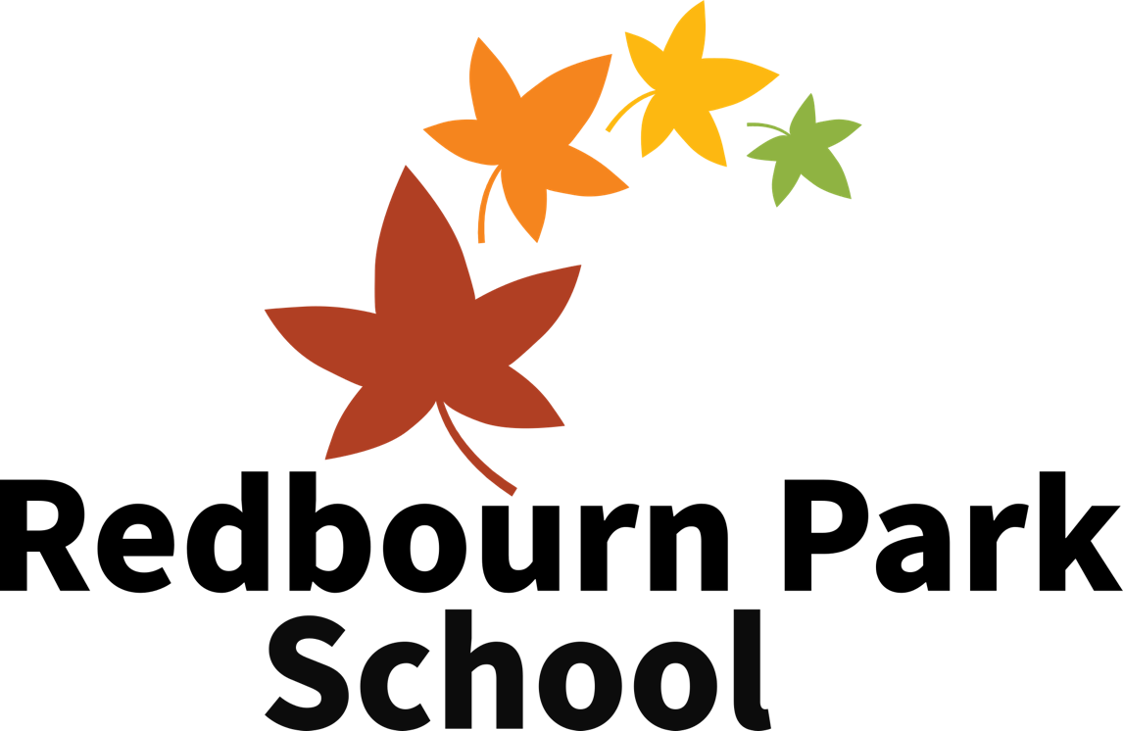
Supporting needs & complex behaviour

See also, who we are, anti-bullying, online safety, physical intervention and attendance policies

Our vision is to provide students with the best opportunities possible to be positive and successful members of their communities. We do this by developing the whole student as well as focusing on their academic development. We do this through high quality, positive teaching and support and three core beliefs underpin everything we do:

Everyone has the potential to achieve

We have high expectations of ourselves and others

We respect ourselves and others

This policy was updated: September 2023
This policy was created: April 2023

INTRODUCTION
Redbourn Park School was founded to offer educational placements that are focused on ensuring students get the very best opportunities we can give them. Having been in education for a long time and worked in a range of complex needs provisions it is clear that the need for high quality provision that is focused on the student and their individual needs is astoundingly high.
With our experience and drive to support the most complex of students, we know we can have a positive impact on our students and the communities around us. This policy aims to set out our approach for parents, staff and other stakeholders so that they can understand our commitment to how we support the children we work with.

WHO WE ARE
At Redbourn Park, we strive to balance academic progress with supporting emotional wellbeing (and behaviour), personal development and lifelong learning. Due to the complex needs of our students, with particular consideration for their anxiety, trauma and autism needs, our approach has three key stages:

Safety – We make them feel safe

Empathy – We meet them where they are

Interest – we make learning & development interesting & rewarding
This approach is both overarching throughout policy and in use day to day, as teachers plan and adapt their lessons throughout. The goal is always to help every student reach their potential by equipping them with all the different tools they need.
These principles underpin everything we do.
There are many different aspects to ensuring progress, but everything comes back to our three steps.

Transitions
Joining a new school after what is typically a very challenging educational journey for our students, is a big step. As a school, we adapt our package significantly for this initial period, offering higher levels of staff support and flexibility around a gradually increasing timetable which is led by families and agreed by school.
We typically aim for a 6-12 school week transition period, taking students through different stages at their own pace. Students may start with one day a week, focusing on confidence, positive relationships and feeling safe before then increasing to a full week over an appropriate period of time, adapted to the progress and readiness of the child. Some students may, and have, started full time after only a visit or two, again outlining our adaptive approach that meets the child where they are.

Personal Development
The inevitable aim is to prepare students for life once they leave school and ensure that they have as much opportunity as possible to achieve and become positive members of their communities and thrive as independently as possible. This is partly done by ensuring they are educated to the highest possible level for each child. Other, perhaps more key elements include ensuring they are able to understand, cope with and interact positively with the world around them.
This is achieved by:
- Supporting their social skills through direct teaching and supported situations.
- Supporting their emotional wellbeing, developing resilience, and acquiring coping strategies.
- Experiencing and developing knowledge of the world around us, both locally and afar.
- Developing a respect and appreciation for other people, communities, beliefs, values, preferences and other differences.
- Setting high expectations through being positive examples, appropriately supporting behaviours and reflecting on positives, negative and ways to improve with pupils.

Behaviour & Personal Development
As a school that caters for students with autism, anxiety and complex needs, sometimes as the result of experiencing trauma, it is imperative to identify the root cause of any behaviour in order to support their social and emotional needs. Therefore, it is of the highest importance that policies with regard to behaviour and supporting emotional needs are flexible, effective and centred on building positive relationships and being endlessly positive.
Our students may also have histories of rejection and exclusion from previous educational settings. In order to meet our students’ complex needs, further considerations are that many of our students have not had any positive experiences of school and developing relationships with staff members can help to make up for some of the development that has been missed. Each student is supported differently, or rather appropriately to their needs, but the key principles for all support will include:
- Unconditional positive regard for our students and everyone we work with.
- Caring relationships with staff that are underpinned by positive support, appropriate boundaries and empathy.
- Consideration of any need that is not being met and the possible years of difficulty that has led the student to their current situation and level of need.
- Communication that is clear, consistent and positive (or in some cases, appropriately passive).
- Consistency in support, interactions and (high) expectations for behaviour and learning – being predictable is very important.
- Cooperation with students to explore their emotions and reflect on how they may have been feeling and working together to overcome challenges or difficult behaviours.

Progress, Outcomes & the Role of Leadership
Leaders use formative assessments against the national curriculum objectives to measure progress towards qualifications and point in time assessments for emotional wellbeing and development to track, analyse and positively impact on progress and development through interventions, adjustments to planning and resources and also focus weeks.
All data that is collected is part of an efficient planning and assessment for the learning process – these methods have been designed to have minimal impact on workload. All progress is reported to governors who explore, challenge and then publish a summary at the end of each term.

Our expectations
Because of the complexities and uniqueness of the behaviour and challenges we face; we have two simple expectations that act as our school rules:
We respect each other, our school and ourselves
We always try our best

PSHCE & SMSC
Social and emotional development is central to our curriculum and ethos. Breakfast, break time, lunch and PSHCE are focal points for the facilitation of this development; however, it is acutely important that social and emotional learning is embedded throughout the entire day.
Developing our students’ social skills and teaching them about healthy living, preparing them for life in modern Britain and enabling them to make positive life choices is of considerable importance. A weekly formal lesson of PSHCE is not enough in a school setting such as ours, which is why we have a values-centred curriculum and a range of opportunities and experiences to support students' development.

Our PSHCE curriculum includes:
- Online safety, adapted to the ability and maturity of the class.
- The development of social skills including managing anger and emotions, building relationships, dealing with conflict and making positive choices, including online as part of online safety education.
- The development of anti-discriminatory understanding including knowledge and understanding of bullying, cyber-bullying, racism, sexism, homophobia, transphobia and religious tolerance.
- Providing opportunities for reflection, thinking, discussion and formal argument.
- Helping our community, supporting charity and helping others.
- Personal health and how to stay healthy with specific focus on nutrition and exercise.
- The development of the understanding of risk and keeping safe in everyday life.
- An understanding of the world of business and consumers through enterprise projects and fundraising for projects and/or charities.
- Carefully planned and differentiated activities ensure that all students begin to view and understand themselves in the context of wider society, in a structured and supportive way.

In addition, our PSHCE curriculum also ensures that students have the opportunity to:
- Contribute to our community through activities such as raising money for local causes and charities.
- Learn about public institutions and services in England (for example, the royal family, government, national health service, fire service, the police).
- Develop an understanding of the importance of tolerance and equality whilst challenging prejudice and discrimination. We teach specific lessons which promote tolerance of different family structures and recognise that whilst not everyone’s families are the same, they should all be respected and valued as part of an inclusive school community.
- Receive independent careers advice to support them in planning their futures.

Formally teach Relationships and Sex Education (RSE) to our students which aims to:
- Help students develop an understanding of the different types of relationships, including family relationships.
- Help students to develop skills in forming and maintaining relationships with others, including their peers.
- Teach students about the changes to their body that occur during puberty.
- Introduce students to reproduction.
- Appropriate learning as discussed with parents at termly parent meetings.

We also link Personal, Social, Health, Economic & Citizenship Economic Education (PSHCE) to Spiritual, Moral, Social & Cultural Development (SMSC) across the curriculum. As well as fulfilling the objectives in our tailored PSHCE schemes of work at all Key Stages, we aim to develop all students’:

Spiritual development (s)
- ability to be reflective about themselves
- use of imagination and creativity in their learning
- willingness to reflect on their experiences

Moral development (m)
- understanding of right and wrong
- respect for the rule of law in modern Britain
- understanding of the consequences of their behaviour and actions

Social development (s)
- use of a range of social skills in different contexts
- willingness to participate, cooperating well with others and being able to resolve conflicts effectively
- understanding of & engagement with the fundamental British values of democracy, mutual respect and tolerance of those with different faiths and beliefs

Cultural development (c)
- understanding and appreciation of the range of different cultures within school, in London and in the United Kingdom
- knowledge of Britain's democratic parliamentary system
- positive participation to artistic, sporting and cultural opportunities
- improving understanding of and showing respect for different faiths and cultural diversity

Values and British Values
Redbourn Park School incorporates the promotion of its values through PSHCE lessons and at any other appropriate opportunities throughout the school year. Each half-term we highlight a different set of values, explore what they mean and why they are important for us as a school and as part of a wider community.
Our values:
Aiming high & community | Equality & morality | Courage & determination
Resilience & reflection | Respect & diversity | Coping with change & wellbeing

British values
- Rule of law
- Individual liberty
- Democracy
- Mutual respect
- Tolerance

Behaviour: a personalised approach
As a school that focuses on a very unique group of children whose needs, abilities, strengths, challenges, opportunities, anxieties, crises, triggers and preferences are all different, it is important to have both an overall approach to behaviour, but also an individualised one.
As such, we have key documents that outline each needs, risks and support strategies to allow staff to follow our ethos, values and policies. These are:
- Risk assessment (live, reviewed at least termly)
Risk assessments outline key needs, any additional risks to consider and ways in which staff can negate these risks.
- Development plan (for each half term)
Development plans outline annual or key targets from EHCP’s and professional assessments that staff are working towards. They also outline any learning projects or themes for the half term ahead and also any focus targets (deficits or areas to secure) and extending or mastery targets.
- Support plan (live, reviewed at least termly)
Support plans firstly describe the behaviours or non-verbal communication we may see due to specific needs, emotions or situations. They also outline what approaches we would take to engage each child with their learning. It considers how they may be feeling or how ready they are to learn and then provide planned strategies to support this child back to a state of being ready to learn.

Behaviour: positives, consequences, reflection & restoration
Rewards and positive consequences play a key role in supporting our students effectively. In order to create a culture where staff focus on celebrating positives, we use points to track and share positive behaviours throughout the day.
Due to our focus on a positive approach and identifying behaviour as communication and need, we focus on removing demand and supporting students to make better decisions and earn rewards for themselves. We track behaviours, incidents and dysregulation so we can properly support students and the complex behaviours we see day to day.
At times, it is important to have a deeper reflection on negative behaviours, not as a punishment but as an opportunity to develop by exploring the incident, how it felt and areas that staff and the student could have taken action to change the outcome. This process is called a reflect and restore and is completed on a form and filed alongside a CPOMS record.

Exclusions, emergency reviews & ending placements
In extreme cases, the head teacher may exclude a student for a fixed term of, typically, one or two days. A fixed-term exclusion is exceptionally rare. When the decision is taken to exclude a student, an explanatory letter is always posted to the parent/carer on the same day – as well as to the placing authority – and homework is provided.
In very exceptional circumstances, such as a student bringing illegal drugs or weapons into our schools, the head teacher and chair of governors may make the decision to permanently exclude.
When we cannot meet a student’s needs, we will call for an emergency annual review with the placing authority to re-evaluate the suitability of the placement and recommend that another provision be sought. This is not the same as exclusion.

Recording and communicating behaviour management events
- General positive behaviour is logged via points system
- Incidents are logged on CPOMS
- Dysregulation is logged on CPOMS
- Physical interventions are logged on CPOMS
- Serious incidents (SLT review 1-5) and incidents of concerning categories such as bullying, and discrimination are logged on CPOMS
- Accidents, injuries and use of first aid are reported using the school’s accident books
- All events logged are analysed by the leadership team on a weekly basis and changes are made proactively and robustly to continually act on reducing incidents.

Physical intervention
This policy must be considered alongside our physical intervention policy. Physical intervention is only used as a last resort. It is not used as a behaviour management strategy – it is used when there is a risk to the safety of a child or others. The focus of this training is on de-escalation rather than needing to physically intervene with children.
Staff receive behaviour support/physical intervention training, and every incident of physical intervention is recorded on a physical intervention form in the physical intervention book, which is reviewed by leaders. This is also communicated to the parent/carer and appropriate professionals. Leaders review the number of incidents, serious incidents and restraints to identify patterns in students, staff, lessons, days and more.

Bullying
This policy must be considered alongside our anti-bullying policy. All types of bullying, including outside of school and all forms of online bullying, must be followed up with the same rigour and using the same processes outlined above. Staff actively create opportunities to check on wellbeing and create a safe space for students to talk about anything that may be making them unhappy.

Child on child abuse
As a School with challenging, anti-social and at times, violent behaviour we have to consider child on child abuse deeply. Whilst some behaviours could be considered an outcome of a diagnosed or documented need, we consider every incident between students as potential abuse and trauma, supporting with appropriate outcomes in line with policies outlined above. We maintain our overall approach in trying to support students to change their behaviours through positive support and reflection but always consider the impact on the abused.

Online safety
This policy must be considered alongside our online safety policy as many online safety incidents will be considered behavioural incidents (many may alternatively/also be safeguarding concerns and should therefore be considered as part of our safeguarding strategy).

Impartial careers information, advice & guidance
Careers guidance is a planned aspect of the PSHCE curriculum for all students, focusing on the range of career opportunities, suitable roles related to skills, qualifications and experiences, goals, next steps and raising aspirations – which links to our values centred curriculum, especially the term’s unit on ‘aiming high and achieving goals’.

Staff training
All staff are trained in supporting our students and their complex needs. We have many more training days compared to other schools and use these to robustly support and train staff. Each September, we offer a comprehensive induction and refresher in therapeutic support, our values, our approach, safeguarding, physical intervention, autism, PDA & trauma informed practice and more. Staff are inducted 1:1 with their line manager when they join throughout the year.
Each half term is followed by an INSET day, which always contains training on safeguarding, supporting students needs, teaching, learning & assessment and specialist areas as needs within the school dictate.

Leadership & governance
A key role of leaders and governors is to ensure the vision values and ethos is present when we are working with students. Essentially, that all our behaviour and teaching support is done in the spirit of who we are.
Another role is also to have a robust overview and understanding behavioural incidents within the school. The CPOMS recording system gives a clear overview of all incidents, allowing leaders to conduct robust analysis of behaviour and also take steps to impact and improve on any patterns that emerge.

Banned items
The school does not permit:
- Real or imitation weapons
- Sprays or aerosols
- Lighters or fire starters
- Games or electronic devices

Bringing these items into school could result in a fixed term exclusion or other appropriate outcome.

Published on
By
Chair of Gov Sig/date
Head Teacher sig/date

Staff read and acknowledged:
Name | Sig/Date

