Planning, Teaching & Assessment
Also see, Who We Are & What We Do policy
Our vision is to provide students with the best opportunities possible to be positive and successful members of their communities. We do this by developing the whole student as well as focusing on their academic development. We do this through high quality, positive teaching and support and three core beliefs underpin everything we do:

Everyone has the potential to achieve

We have high expectations of ourselves and others

We respect ourselves and others

This policy was updated on: September 2023
This policy was created on: January 2023

Introduction
This document outlines the processes and expectations around planning teaching and assessment, including our curriculum, schemes of work, planning, resources to support quality of teaching, pedagogy, assessment, feedback and ensuring learning is embedded.

Planning

Curriculum & Scheme of work
We teach all of the national curriculum subjects and our scheme of work is based on the subjects and expectations in the national curriculum for each year and key stage. It plans for the levels that each student should reach each year, leading towards when they leave us, at the end of key stage 2 (year 6 / 11 yo).
In practice, many of our students have significant deficits either through specific learning difficulties, anxieties or because of time out of school due to challenges they have faced. As such, we have a scheme of work that provides a clear, sequenced curriculum to support high levels of progress but also a targeted ‘focus and mastery’ element to planning and teaching.
We have a KS3 curriculum available to those ready to achieve to that level and the long term aim is to provide education to at least GCSE level, with students supported to achieve as highly as possible as both an academic and as an individual who can thrive in the world we live in.

Initial Assessment - Baseline
When each student is placed, they are formatively assessed against the national curriculum for evidence of prior learning, deficits and areas of high ability. This is important because students with complex profiles have often missed out on parts of their education so assessing for strengths and challenges is key.
We use a combination of formative assessment from lessons and summative assessments in the form of in class mini tests and our online program, Century.

Termly planning & student development plans
Once a baseline assessment is complete, teachers follow their scheme of work for the term and termly basis. The plan identifies all learning objectives from each block of learning and teachers adapt to pupils’ levels as well as planning to specific areas of focus and mastery.
Development plans identify overall areas of learning for the term, key focuses and wider targets drawn from wellbeing, EHCP and therapy/specialist input.

Teaching
Teaching is expected to a high standard against both the teacher’s standards and specialist expectations within specific SEN expertise and our own ethos. All planning should be specific to each student/group and is based around each student’s needs and preferences.

Pedagogy
We focus on simple steps to engaging, exploring and embedding learning.
- All teaching is underpinned by clear schemes of works and well sequenced learning.
- All teaching is underpinned by a developed understanding of each child’s complex needs, with key input for EHCP’s and professional assessments.
- Lesson plans follow the scheme but must be adapted to individuals each lesson.
- Lesson plans/structure should typically consist of an introduction, main input and then plenary. However, the structure, timing and input must consider the needs, key targets and professional assessments for each child.
- Each lesson focuses on:
  - Introducing the concept and/or check for previous knowledge
  - Specifying and adapting the lesson to the needs and knowledge of students
  - Explore and apply the learning to asses and embed learning
  - Check students can remember, review and reflect on the learning, short and long term

Introduce concept

Check for knowledge

Specify & adapt

Explore & apply

Remember, review, reflect

Evidencing learning
Students’ work is recorded in learning folders. Learning folders consist of daily learning that has been completed and learning records where learning has been discussion, physical or non-worksheet/book based. All students have their own objective(s) identified for each lesson (although they will typically match with adaptation), with assessments, feedback and reflection with students to act as marking and feedback also for each session.

Quality of Teaching
Teaching development cycles are implemented half termly, with learning walks identifying strengths and areas for improvement in teaching and then with planned teaching improvement interventions, teaching is robustly supported and expected to be reviewed and impacted on as part of a half termly cycle and Teaching Improvement Plan (TIP).
We acknowledge the challenge in schools finding highly skilled, experienced and qualified teachers and understand that in order to ensure teaching is to a high standard, a significant CPD program is required (and in place) as well as teaching, planning and assessment resources to support subject knowledge and skilful teaching.
Areas that we observe, explore and focus on are:
- Environment
- Displays
- Expectations & objectives
- Engagement & supporting learning
- Subject knowledge & planning
- Adaptation
- Resources & scaffolding
- Assessment for learning & reflections
- Social, emotional and behavioural support
- Cross curriculum & Quality of life learning
- Learning records

Assessment

Daily review
Engagement, progress and evidence of learning is reviewed each day with a view to update and adapt learning for the following session. Reviewing a student’s progress towards an objective is key to maximising progress, ensuring teachers push more able learners on and adapt lessons for those who need more input.

Half term review – development plans
Each half term teachers review and update development plans to ensure EHCP, specialist and focus/mastery targets are a key part of our day to day and overall plan for each pupil.

Termly Progress & Report
Each term, progress is measured. Tracking is done via formative assessment daily as well as assessment weeks at the end of each term where teachers use a combination of formative and well structured summative assessments. However, reading and phonics is done via a DFE approved scheme so has an adapted system for measuring progress.

Robust reflection
Each session, or at appropriate intervals (perhaps at the achievement of an objective), teachers review learning and next steps. This, in comparison to written feedback, is intended to give a deeper reflection on learning and progress with students. Taking the opportunity to have a conversation around learning not only accounts for students who have communication issues but robustly embeds learning further, offers a positive experience around success and gives the students a clear understanding of how they can improve and take ownership for their own progress.

Annual review
Every student at Redbourn Park has an EHCP and will be subject to an annual review in which their levels, academic progress and other developmental targets will be reviewed.

Reading
Students will be assessed in reading via phonics screening and reading assessments to allow teachers to effectively plan and adapt for each student. This assessment will dictate whether the priority is to focus a phonics program or a specific level on the reading scheme.
Our phonics program was developed and acquired from Twinkl and is a fully comprehensive, synthetic phonics teaching programme, with a range of planning, resources and assessment tools provided.
Reading is progressed using four main methods:
Reading or being read to  (Daily) | Phonics program  (most days)
Exposure to wider vocabulary  (where appropriate) | Indirect reading opportunities  (where appropriate)
Where children are late to reading, or have a considerable deficit in reading, developing this may become a priority. In practice, this means they would still continue through the English curriculum with appropriate support, but a large proportion of their English time, and additional interventions would be focused on reading, phonics and language.

Remote learning
Where a student is restricted from attending school through unavoidable circumstances, such as isolating due to an illness, potential illness or other reason supported by government guidance or best practice.
The school will put in place appropriate learning programs on a case-by-case basis, considering a few key factors:
- Nature of absence
- Current home situation
- Available resources, technology and support at home
- Available resources, technology and support at school

The school will do everything possible to fulfil a full timetable but acknowledge the challenges of learning within the home environment. Depending on the situation the school may suggest:
- Online tutoring
- 1:1 home visits & tutoring
- Home working packs
- Sending resources, technology and other necessities home
- Wellbeing check ins
- Online social groups

It is important to consider each situation individually, balancing the challenges with high expectations. SLT should review any home learners each week to ensure potential is maximised.

Appendix 1

The process
- Baseline / assess | Gain a robust initial understanding of a child’s academic, social, emotional and special education needs.  Use EHCP, parent interview, baseline assessments, specialist assessments.
- Plans | Create a risk assessment based on paperwork  Review/update risk assessment  Create pupil profile  Review/update pupil profile  Create development plan  Use schemes of work, weekly plans and daily plans and resources for each subject  Adapt plans to L/M/H students and key areas of focus/mastery
- Teach | Each session, use the lesson plan whilst adapting around the development plan, RA and pupil profile  Teach:  - Introduce the key concept/learning and aims & check for prior knowledge  - Teach key learning with adaptation to previous knowledge  - Explore and apply learning  - Check students can remember it, can they review it, can they reflect on it (and how they found it) – mark for correctness & feedback/reflect on learning during lesson
- Assess | Live review & reflection as with point 5 above  Review the lesson, engagement and progress in the lessons  Adapt next session to consolidate knowledge not yet embedded/learned
- Plans | Follow scheme and sequence  Adapt as per review, reflection and daily/weekly/termly assessment
- Teach | Repeat daily/weekly cycle
- Assess
- Plans
- Half termly | Review development plan and update
- Termly | Assessment weeks  Review and update risk assessments  Review and update pupil profile  Review and update academic progress

Appendix 2
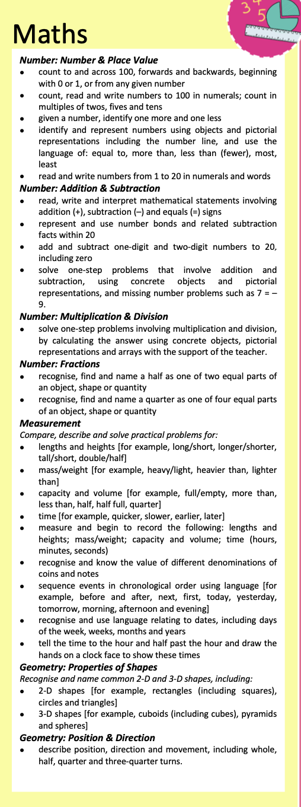
Sample overview

Sample mathematics long term plan
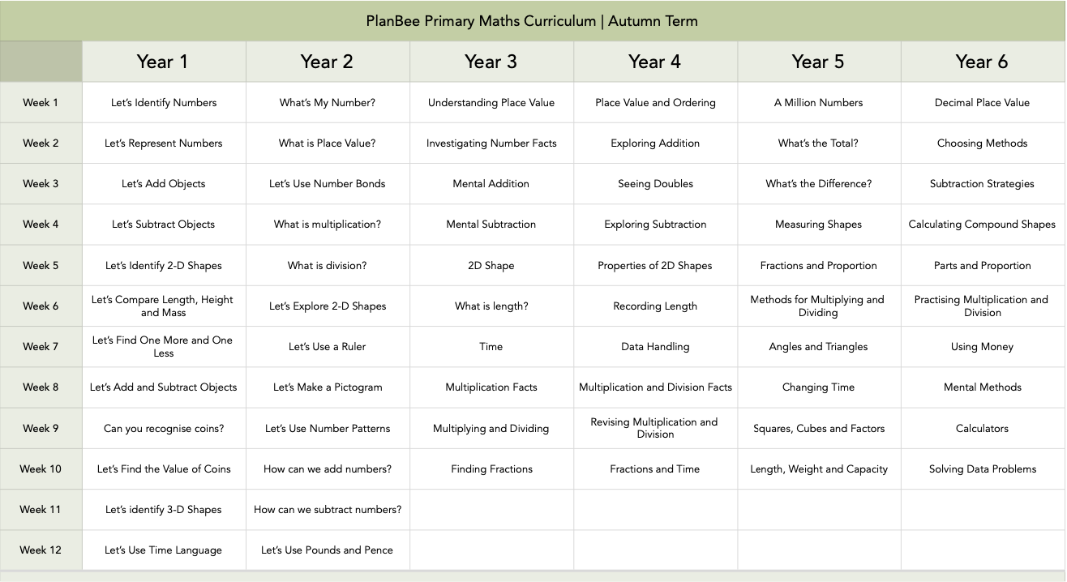
Sample mathematics medium term plan
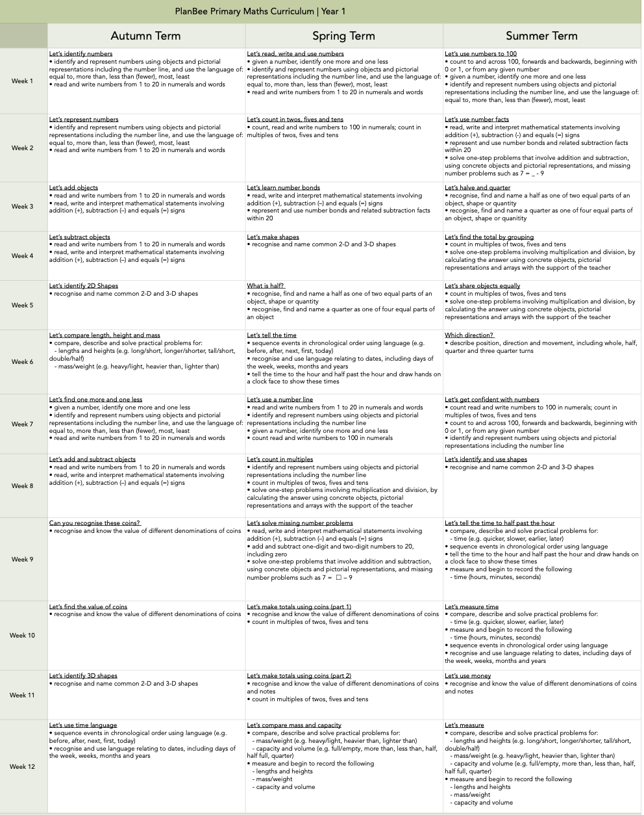
Sample development plan
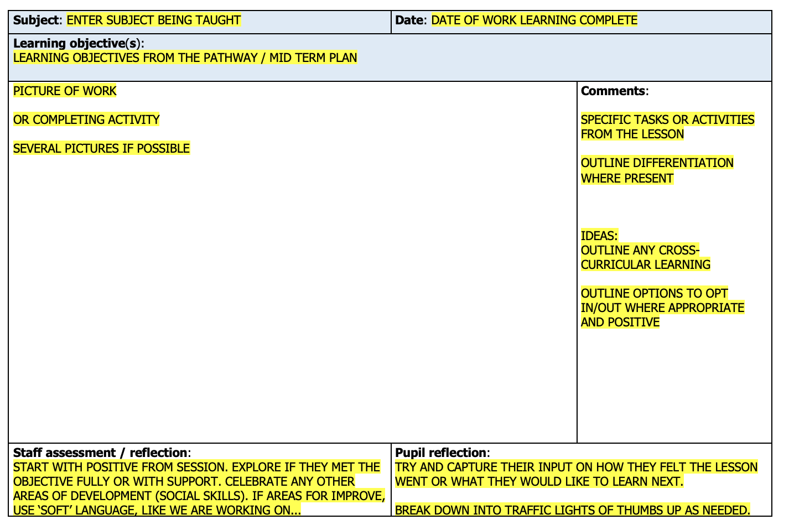
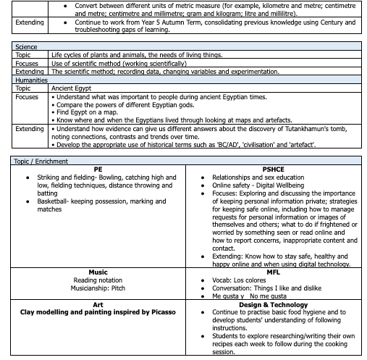
Learning record template
Sample daily plan resource
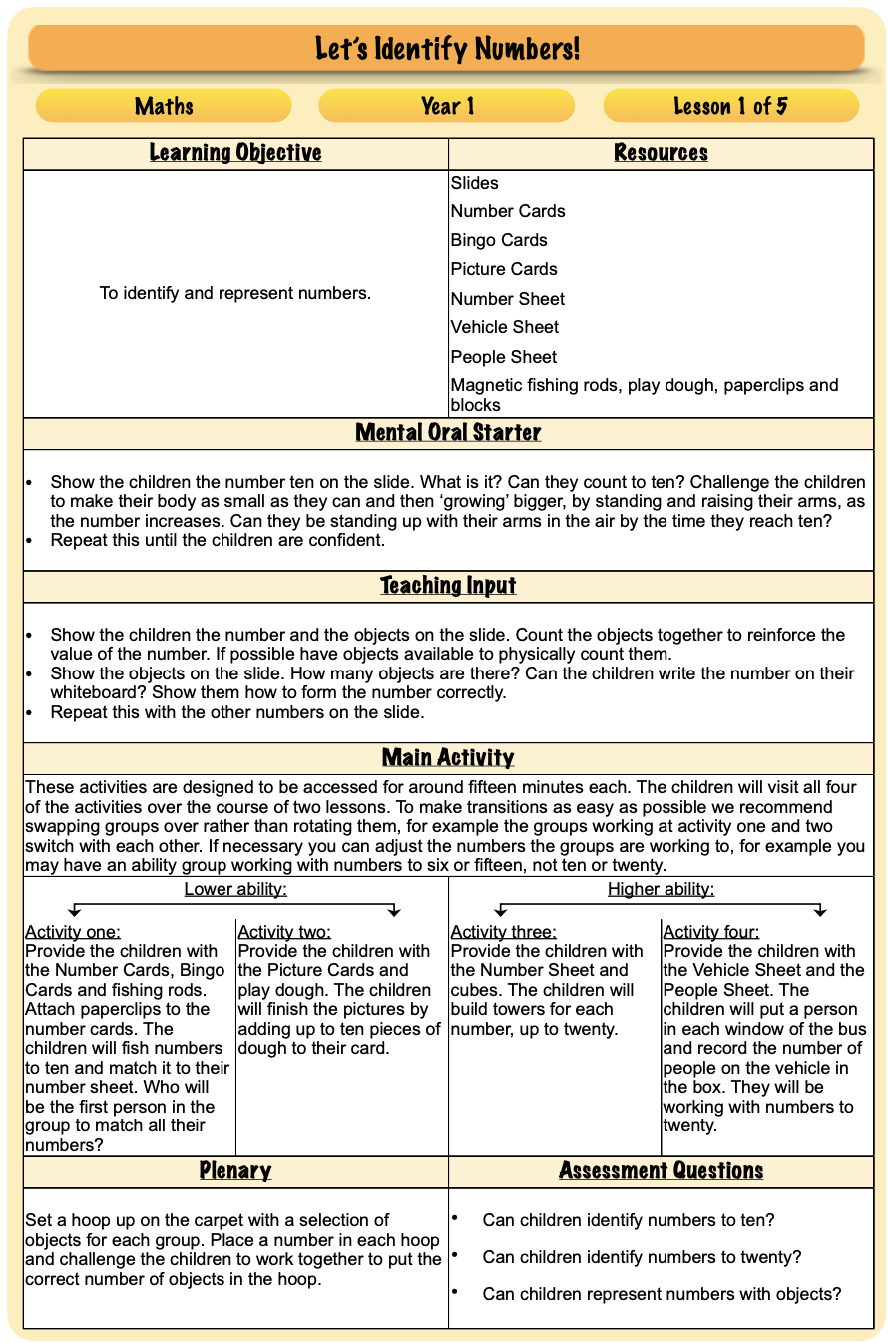

Sample daily plan/assessment addition by teacher
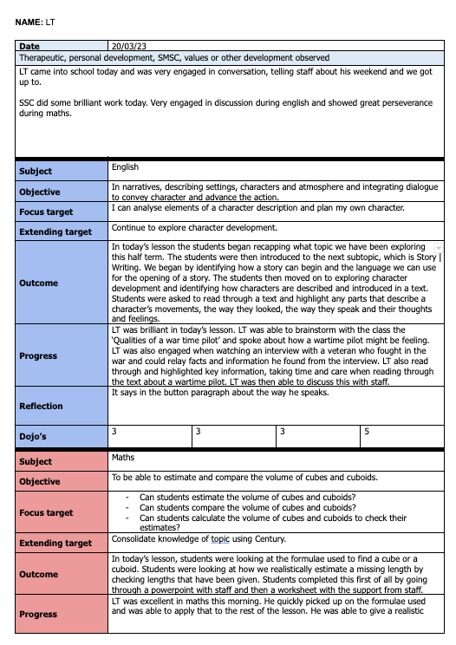
Notes on progress outside of academic, technical or vocational seen that day
Subject and learning objective of the lesson
Focus target – area of deficit being targeted or consolidating learning
Extending target – area of to extend if learning is accelerated
Outcome – what was planned or what happened in the lesson
Progress – what progress was made or evidence was there to meet the LO, focus or extending targets
Reflection – students feedback from discussion / active feedback in class
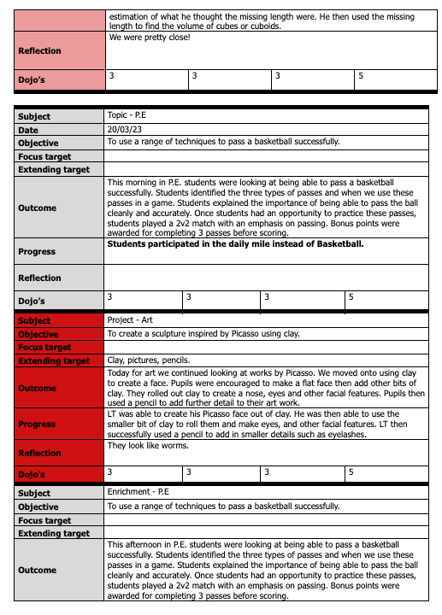

Sample Support Plan
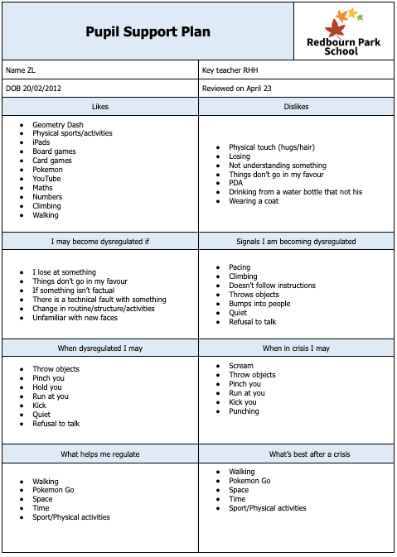
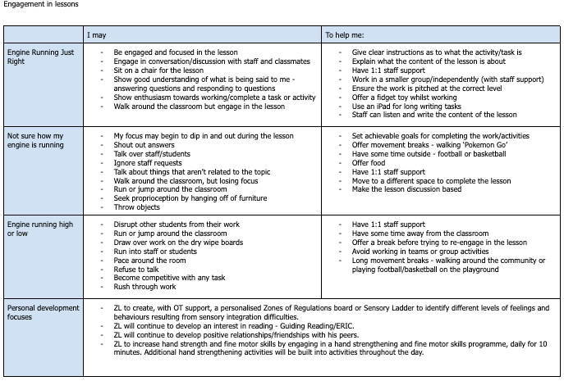

Published on
By
Chair of Gov Sig/date
Head Teacher sig/date

Staff read and acknowledged:
Name | Sig/Date

