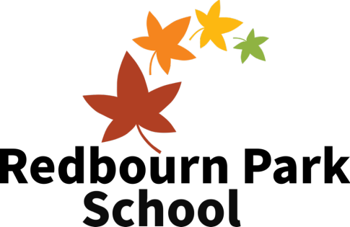
Job Description

Tutor, SEN
Summary
Tutors are key to the support and effective teaching of students with SEN needs. Where teachers lead the classes overall, tutors form the strong structure of the team that supports all aspects of the child’s development. Working both in a team, leading small groups or 1:1 sessions under the guidance of the teacher.

Someone with SEN experience is ideally suited for the role and the nature of a small school calls for someone who is flexible, resilient and thrives in being able to lead a class with a high level of independence. It will require energy, outstanding communication skills and a willingness to develop their own abilities in line with the school’s aims, values and ethos.
Responsibilities
You will:
- Facilitate effective, differentiated and pupil-centred learning one to one or in small groups.

- Support behaviour positively and in line with the school’s ethos and procedures.

- Support on ensuring the learning environment is attractive, positive & uncluttered.

- Role-model the values the school stands for and to be a role-model of outstanding professionalism.
- Take a key role in the pastoral care of children in your class.

- Co-ordinate and oversee the organisation of educational visits for your class, including risk assessments as appropriate.

- Support the creation of a well-managed, secure and happy classroom where priority is given to the quality of the learning environment, maximising opportunities for children to learn.

- Encourage, develop and support relationships between families, staff and children.

- Report to and involve families in the development and achievement of children.

- Support good behaviour in the classroom in accordance with the schools’ behaviour policy

- Participate and engage with the performance management process.

- Work as a member of the team to ensure consistency and continuity across the curriculum.

- Attend and participate in meetings and briefings as appropriate

- Take part in the school staff development programme by participating in opportunities for continuous professional development, including necessary training such as Team Teach, first-aid etc.
- Be knowledgeable and supportive of all school policies and procedures.

- Contribute to the school’s self-evaluation and ongoing improvement.

- Oversee target setting for raising achievement of your children.

- Be aware of, and comply with, all policies and procedures related to child protection & safeguarding, bullying, data protection & confidentiality.

- Comply with any reasonable request from the leadership team to undertake work of a similar level that is not specified in this job description.
This job description is not exhaustive, and the post holder may be required to undertake other duties as reasonably required by the leadership team. All posts are subject to Enhanced DBS checks in addition to a range of other vetting checks. As a small school the expectation to work as a community and beyond the typical scope of a teaching role is more prevalent and is expected to be undertaken in the spirit of the organisation and what it is trying to achieve for its students.

Person Specification

Tutor, SEN
Essential Skills and Character
- Extremely strong ability to provide educational support and work successfully with children with SEN.
- Outstanding communication skills (with children, families & professionals).

- Outstanding organisational skills (including meeting deadlines).

- Strong ability to work constructively and collaboratively at all times as part or as the lead of a unified team.

- Strong academic skills to support teaching across the curriculum.

- Reflective practitioner eager to progress professionally.

- Able to recognise own training needs and willing to undergo relevant training.

- Attention to detail, including in terms of presentation, punctuality and supporting the maintenance of an attractive environment for learning.
- Ability to support families and carers of children with challenging behaviour.

- Ability to cope in high pressure, highly stressful contexts.

- Creative and imaginative thinker in terms of children-centred teaching.

- A commitment to promoting and safeguarding the welfare of children.

- Able to prepare effective written and visual teaching materials including the effective use of ICT

Knowledge
- Clear understanding of child development, learning and children with SEN and associated special educational needs.

- Clear understanding of a range of teaching, assessment and behaviour management strategies that facilitate effective learning & progress.

Qualifications & Experience
- A degree in a core subject (ideal).

- A range of experience in supporting the primary curriculum or a secondary subject area to children with SEN (essential).
- Further training or qualifications related to SEN (desirable).

