First Aid policy

Including policies and procedures on GDPR

See also, Online Safety Policy

Our vision is to provide students with the best opportunities possible to be positive and successful members of their communities. We do this by developing the whole student as well as focusing on their academic development. We do this through high quality, positive teaching and support and three core beliefs underpin everything we do:

Everyone has the potential to achieve

We have high expectations of ourselves and others

We respect ourselves and others

This policy was reviewed on: Sept 2023
This policy was created on: October 2020

Introduction
Redbourn Park School is committed to caring for, and protecting, the health, safety and welfare of its students, staff and visitors. We confirm our adherence to the following standards at all times:
- To make practical arrangements for the provision of First Aid on our premises, during off-site learning and on school visits.
- To ensure that trained First Aid staff renew, update or extend their qualifications at least every three years.
- To have a First Aider on site at all times.
- To ensure that a trained first aider accompanies every off-site visit and activity. To record accidents and illnesses appropriately, reporting to parents and the Health & Safety Executive under the Reporting of Injuries, Diseases and Dangerous Occurrences Regulations (1995).
- To provide accessible first aid kits at various locations on site, along with a portable kit for trips, excursions and sport.
- To record and make arrangements for students and staff with specific medical conditions.
- To deal with the disposal of bodily fluids and other medical waste accordingly, providing facilities for the hygienic and safe practice of first aid.
- To contact the medical emergency services if they are needed, informing next of kin immediately in such a situation.
- To communicate clearly to students and staff where they can find medical assistance if a person is ill or an accident has occurred.
- To communicate clearly in writing to parents or guardians if a child has sustained a bump to the head at school, however minor.

Location of First Aid Facilities
The First Aid room is located in the main room downstairs, next to the toilets. This includes; a bed, first aid supplies, a water supply and sink, an adjacent bathroom and hygiene supplies such as gloves and paper towels. First aid kits are available from the office.

Responsibilities of the Trained First Aiders
- Provide appropriate care for students of staff who are ill or sustain and injury
- Record all accidents in the accident book (to be found in the office). In the event of any injury to the head, however minor, ensure that a note from the school is sent home to parents/carers and logged on the first aid form.
- Make arrangements with parents/carers to collect children and take them home if they are deemed too unwell to continue the school day.
- Inform the appointed person of all incidents where first aid has been administered.

Responsibilities of the Leadership Team
- Ensure that all staff and students are familiar with the school’s first aid and medical procedures.
- Ensure that all staff are familiar with measure to provide appropriate care for students with particular medical needs
- Ensure that a list is maintained and available to staff of all students with particular medical needs and appropriate measures needed to care for them.
- Monitor and re-stock supplies and ensure that first aid kits are replenished.
- Ensure that the school has an adequate number of appropriately trained First Aiders.
- Co-ordinate First Aiders and arrange for training to be renewed as necessary.
- Maintain adequate facilities.
- Ensure that correct provision is made for students with special medical requirements both in school and on off-site visits.
- On a monthly basis, review first aid records to identify any trends or patterns and report to the Governors meetings
- Fulfil the school’s commitment to report to RIDDOR, as described below
- Liaise with managers of external facilities, such as the local sports facilities, to ensure appropriate first aid provision.
- Contact emergency medical services as required.
- Maintain an up-to-date knowledge and understanding of guidance and advice from appropriate agencies

What to do in the case of an accident, injury or illness
A member of staff or student witnessing an accident, injury or illness should immediately contact a named trained first aider (see above). Any student or member of staff sustaining an injury whilst at school should be seen by a first aider who will provide immediate first aid and summon additional help as needed. The student or member of staff should not be left unattended. The first aider will organise an injured student’s transfer to the first aid room if possible and appropriate and to hospital in the case of an emergency. Parents and/or carers should be informed as necessary by telephone by school staff. This will be followed up in writing and a record kept at school. A written record of all accidents and injuries is maintained in the accident book and all communication logged.

Contacting parents/carers
Parents/carer and or carers should be informed by telephone as soon as possible after an emergency or following a serious/significant injury including:
- Head injury (a head injury advice sheet should be given to any student who sustains a head injury)
- Suspected sprain or fracture
- Following a fall from height
- Dental injury
- Any form of seizure
- Severe asthma attack
- Difficulty breathing
- Bleeding injury
- Loss of consciousness
- If the student is generally unwell
- Incidents of self-harm

If non-emergency transportation is required, an authorised taxi service or school vehicle will be used if parents/carers are delayed. A member of staff will accompany the student until a parent arrives. Parents/carers can be informed of smaller incidents at the end of the school day by a member of staff.

Contacting the Emergency Services
An ambulance should be called for any condition listed above or for any injury that requires emergency treatment. Any student taken to hospital by ambulance must be accompanied by a member of staff until a parent arrives. All cases of a student becoming unconscious, must be taken to hospital.

Accident reporting
The accident book must be completed for any accident or injury occurring at school, at the local sports facilities, or on a school trip. This includes any accident involving staff or visitors. The accident book will be monitored by the appointed person as certain injuries require reporting (RIDDOR requirements). All communication will be logged, including a log of the incident.

Students who are unwell in school
Any student who is unwell cannot be left to rest unsupervised in the sick room. If a student becomes unwell, a parent/carer should be contacted as soon as possible by the appointed person, or a member of the leadership team. Anyone not well enough to be in school should be collected as soon as possible by a parent/carer or member of home staff. A log must be made of any student going home early due to being unwell.

First Aid equipment and materials
All staff are responsible for oversight of stocking and checking the first aid kits. Staff are asked to notify the head when supplies have been used in order that they can be restocked. Contents of the first aid boxes are checked weekly by the staff member responsible for health and safety within the school and restocked at that time.

First aid for school trips
The trip organiser must ensure that at least one adult accompanying the trip has an appropriate First Aid qualification and undertake a risk assessment to ensure an appropriate level of first aid cover, with reference to the educational visits policy, which includes further guidance. This must be returned to the first aid room and a first aider must review any need for replenishing on return. Any accidents/injuries must be reported to the appointed person and to parents and documented in the accident book in accordance with this policy. RIDDOR guidelines for reporting accidents must be adhered to. For any major accident or injury, the appropriate health & safety procedure must be followed.

Students using crutches or having limited mobility
Parents/carers must inform the school of the nature of injury and the anticipated duration of immobility. Information about the condition will be discussed in staff meetings to enable teachers to be fully aware of the student’s needs. Arrangements will be made for the student to arrive/leave lessons early to allow for a safe transfer around school. Parents/carers must inform the school of any particular difficulties.

Emergency care plans
The appointed person ensures that staff are made aware of any student with an emergency care plan. For example, a student who has sudor-seizures has an NHS care plan – which must be adhered to by all staff. These care plans are held on the google drive which all staff have access to.

Students with medical conditions
Any key medical information is on google drive in a students individual file, information will be in their care plans and/or risk assessments.

Dealing with body fluids
In order to maintain protection from disease, all body fluids should be considered infected. To prevent contact with body fluids the following guidelines should be followed.
- When dealing with any body fluids wear disposable gloves.
- Wash hands thoroughly with soap and warm water after the incident.
- Keep any abrasions covered with a plaster.
- Spills of the following body fluids must be cleaned up immediately.

Bodily fluids include blood, faeces, nasal and eye discharges, saliva, vomit. Disposable towels should be used to soak up the excess, and then the area should be treated with a disinfectant solution. Never use a mop for cleaning up blood and body fluid spillages. All contaminated material should be disposed of in a yellow clinical waste bag (available in all 1st aid boxes) then placed in the waste bin in the first aid room. Avoid getting any body fluids in your eyes, nose, mouth or on any open sores. If a splash occurs, wash the area well with soap and water or irrigate with copious amounts of saline.

Infectious diseases
If a child is suspected of having an infectious disease or transmissible ailment, advice should be sought from the Senior Leadership Team who will follow the Health Protection Agency guidelines below to reduce the transmission of infectious diseases to other students and staff.
Illness | Period of Containment | Comments
Chickenpox | Should be assessed by a GP and there is no return until vesicles have crusted over | Pregnant women up to 20 weeks and those in the last 3 weeks of pregnancy should inform their midwife that they have been in contact with chickenpox. Any children being treated for cancer or on high doses of steroids should also seek medical advice.
Measles | 5 days from onset of rash | Any children being treated for cancer or on high doses of steroids must seek medical advice
Hand, foot and mouth | May attend school | Local authority/PHE will be contacted if a number of cases are reported
Scarlet Fever | 5 days after commencing antibiotics | Antibiotic treatment recommended
Diarrhoea and/or vomiting | 48 hours after last episode
Ring worm | At least 24 hours after starting treatment | Ring worm is contagious whilst a rash is present but may return if the rash can be covered
Head Lice | Until treated | Parents will be expected to collect students when head lice are noticed but can return the next day if treated
Conjunctivitis | Whilst symptoms present
Influenza | Whilst symptoms present | Consult GP if symptoms persist
Tonsillitis | Consult GP
Cold, flu and COVID 19 | Whilst symptoms present | Government, DFE and local guidance removes all restrictions on positive cases and symptoms. Continue to monitor and respond appropriately.

MEDICATION IN SCHOOL
The school aims to support as far as possible, and maintain the safety of, students who require medication during the school day. Only prescription medication will be supported in school, we will not store or dispense any non-prescription medication.
However, it should be noted that:
- No child should be given any medication without their parent/carers/guardians written consent.
- Any medication to be administered will be discussed with leaders on a case by case basis, focusing on the most appropriate processes to be put in place around the child and school.
- Parents/carers must be given written confirmation of any medication administered at school, a copy of which will be kept on the student’s file (Appendix 2, to be adapted around medication need).
- The form for filling medication must identify type and amount of medication given to school, dosage and timings and appropriate storage.
- Form should also record dosage times, records of administration of medication and amount returned to parents.

Children will need to take medication during the school day e.g. antibiotics. However, wherever possible the timing and dosage should be arranged so that the medication can be administered at home.

Administration of prescription only medication
The medication must be checked before administration by the member of staff confirming the medication name, student name, dose, time to be administered and the expiry date.
- Wash hands.
- Confirm that the student’s name matches the name on the medication
- Explain to the student that his or her parents have requested the administration of the medication.
- Document, date and sign for what has been administered.
- Ensure that the medication is correctly stored in a locked drawer or cupboard, out of the reach of students.
- Antibiotics and any other medication which requires refrigeration should be stored in the fridge in the staff room. All medication should be clearly labelled with the student’s name and dosage.
- Parents should be asked to dispose of any out of date medication.

Emergency Medication
It is the parents’ responsibility to inform the school of any long-term medical condition that may require regular or emergency medication to be given. In these circumstances a health care plan may be required, and this will be completed and agreed with parents.

Guidelines for reporting: RIDDOR (Reporting of Injuries, Diseases and Dangerous Occurrences Regulations 2003)
By law any of the following accidents or injuries to students, staff, visitors, members of the public or other people not at work requires notification to be sent to the Health and Safety executive by phone, fax, email or letter.
Major injuries from schedule 1 of the regulations:
- Any fracture, other than to the fingers, thumbs or toes.
- Any amputation.
- Dislocation of the shoulder, hip, knee or spine.
- Loss of sight (whether temporary or permanent)
- A chemical or hot metal burn to the eye or any penetrating injury to the eye.
- Any injury resulting from an electric shock or electrical burn (including any electrical burn caused by arcing or arcing products, leading to unconsciousness or requiring resuscitation or admittance to hospital for more than 24 hours.
- Any other injury leading to hypothermia, heat induced illness or to unconsciousness requiring resuscitation or admittance to hospital for more than 24 hours
- Any other injury lasting over 3 days
- Loss of consciousness caused by asphyxia or by exposure to a harmful substance or biological agent.
- Either of the following conditions which result from the absorption of any substance by inhalation, ingestion or through the skin:
- Acute illness requiring medical treatment; or o Loss of consciousness
- Acute illness which requires medical treatment where there is reason to believe that this resulted from exposure to a biological agent or its toxins or infected material.
- Death
- A specified dangerous occurrence, where something happened which did not result in an injury, but could have done.

APPENDIX 1 : Guidance to staff on particular medical conditions

ALLERGIC REACTIONS
Symptoms and treatment of a mild allergic reaction:
- Rash
- Flushing of the skin
- Itching or irritation
If the student has a care plan, follow the guidance provided and agreed by parents. Administer the prescribed dose of antihistamine to a child who displays these mild symptoms only. Make a note of the type of medication, dose given, date, and time the medication was administered. Complete and sign the appropriate medication forms, as detailed in the policy. Observe the child closely for 30 minutes to ensure symptoms subside.

SELF-HARM
Below is a non-exhaustive list of some of the behaviours that some people might consider to be self-harm:
- Scratching or picking skin
- Cutting body
- Tying something around body
- Inserting things into body
- Scouring/scrubbing body excessively
- Hitting, punching self
- Pulling out hair
- Over/under eating
- Excessive drinking of alcohol
- Taking non-prescription drugs
- Burning or scalding body
- Hitting walls with head
- Taking an overdose or swallowing something dangerous
- Self-strangulation
- Risky behaviours such as running into the road

Action to be taken. (refer to the Schools Self-Harm process for more details)
- Locate student
- Call for help from colleague/Emergency Services/GP
- Administer First Aid
- Keep calm and give reassurance – to the individual student and to those who might be affected by witnessing self-harm
- Log injury and inform DSL (Designated Safeguarding Lead)
- Assess risk
- Ensure full handover is confidentially passed onto care home/Parent/Carer

ASTHMA MANAGEMENT
The school recognises that asthma is a serious but controllable condition and the school welcomes any student with asthma. The school ensures that all students with asthma can and do fully participate in all aspects of school life, including any out of school activities. Taking part in PE is an important part of school life for all students and students with asthma are encouraged to participate fully in all PE lessons. Teaching staff will be aware of any child with asthma from a list of students with medical conditions kept in the staff room. The school has a smoke free policy.

Trigger factors
- Change in weather conditions
- Animal fur
- Having a cold or chest infection
- Exercise
- Pollen
- Chemicals
- Air pollutants
- Emotional situations
- Excitement

General considerations
Students with asthma need immediate access to their reliever inhaler. It is the parents’ responsibility to ensure that the school is provided with a named, in-date reliever inhaler, which is kept in the classroom, not locked away and always accessible to the student. Teaching staff should be aware of a child's trigger factors and try to avoid any situation that may cause a student to have an asthma attack. It is the parents’ responsibility to provide a new inhaler when out of date. Students must be made aware of where their inhaler is kept and this medication must be taken on any out of school activities.

As appropriate for their age and maturity, students are encouraged to be responsible for their reliever inhaler, which is to be brought to school and kept in a school bag to be used as required. A spare named inhaler should be brought to school and given to the class teacher for use if the student’s inhaler is lost or forgotten.

Recognising an asthma attack
- Student unable to continue an activity
- Difficulty in breathing
- Chest may feel tight
- Possible wheeze
- Difficulty speaking
- Increased anxiety
- Coughing, sometimes persistently

Action to be taken
- Ensure that prescribed reliever medication (usually blue) is taken promptly.
- Reassure the student.
- Encourage the student to adopt a position which is best for them-usually sitting upright.
- Wait five minutes. If symptoms disappear the student can resume normal activities.
- If symptoms have improved but not completely disappeared, inform parents and give another dose of their inhaler and call the appointed person or a first aider if they are not available.
- Loosen any tight clothing.
- If there is no improvement in 5-10 minutes continue to make sure the student takes one puff of their reliever inhaler every minute for five minutes or until symptoms improve.
- Call an ambulance.
- Accompany students to hospital and await the arrival of a parent.

SEIZURE MANAGEMENT

How to recognise a seizure
There are several types of epilepsy, but seizures are usually recognisable by the following symptoms:
- Students may appear confused and fall to the ground.
- Slow noisy breathing.
- Possible blue colouring around the mouth returning to normal as breathing returns to normal.
- Rigid muscle spasms.
- Twitching of one or more limbs or face
- Possible incontinence.

A student diagnosed with epilepsy or pseudo-seizures will have an emergency care plan.

Action to be taken (For specific students see their individual care plans)
- Send for an ambulance;
- if this is a student’s first seizure,
- if a student known to have epilepsy has a seizure lasting for more than five minutes or
- if an injury occurs.
- Seek the help of the appointed person or a first aider.
- Help the student to the floor.
- Do not try to stop seizures.
- Do not put anything into the mouth of the student.
- Move any other students away and maintain student’s dignity.
- Protect the student from any danger.
- As the seizure subsides, gently place them in the recovery position to maintain the airway.
- Allow the patient to rest as necessary.
- Inform parents.
- Call 999 if you are concerned.
- Describe the event and its duration to the paramedic team on arrival.
- Reassure other students and staff.
- Accompany students to hospital and await the arrival of a parent.

APPENDIX 2: medication form
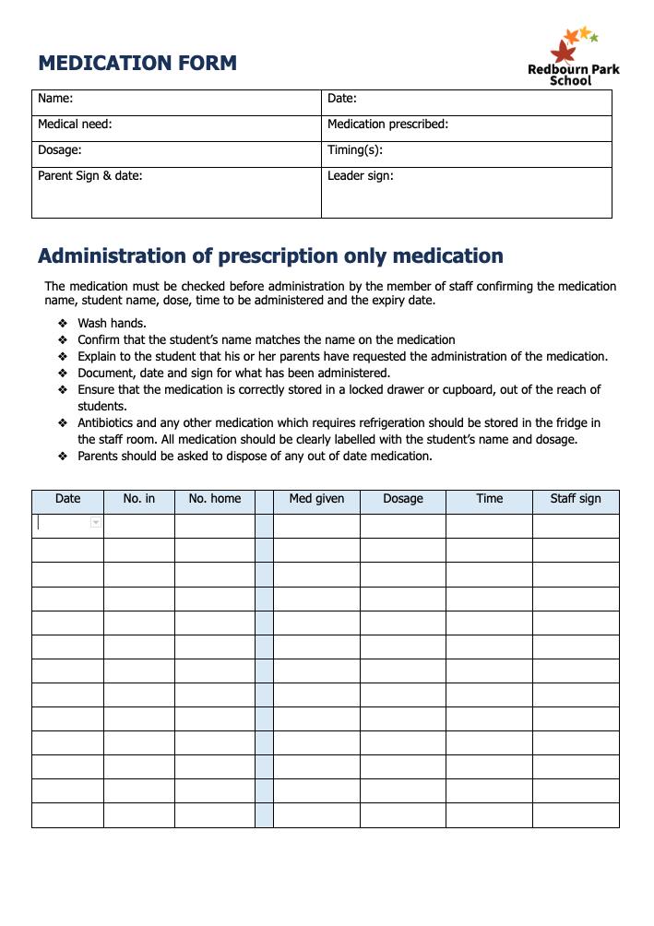

Published on
By
Chair of Gov Sig/date
Head Teacher sig/date

Staff read and acknowledged:
Name | Sig/Date

